< RATB >

Epidemiological definition
Indicator name | Bacterial antibiotic resistance
Justification | Bacterial resistance is the ability of bacteria to resist the effects of antibiotics or biocides that are intended to kill or control them.  The term multiple resistance (MR) or multi-resistance is used when a bacterial strain is resistant to several different antimicrobials or antimicrobial classes.  Targets: all bacteria isolated in a diagnostic sample and requiring an antibiotic susceptibility test, with particular emphasis on meticillin-resistant staphylococcus (MRSA) and extended-spectrum beta-lactamase-producing enterobacteria (EBLSE).  Indicators: percentage of resistance within the species, in addition to incidence in relation to activity, by collecting data on all strains, susceptible AND resistant strains.  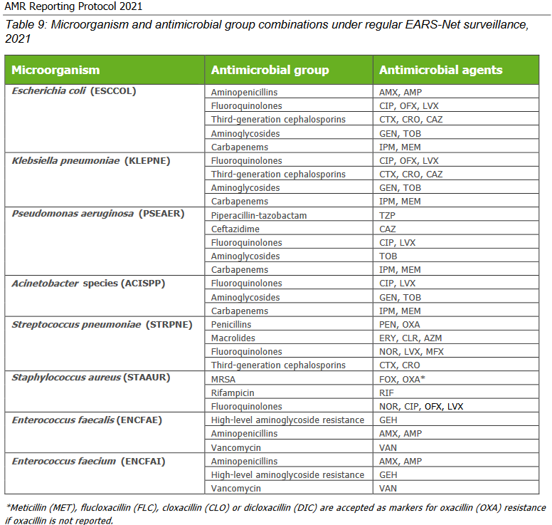  https://www.ecdc.europa.eu/sites/default/files/documents/ears-net-reporting-protocol-2021.pdf  National strategy for the prevention of infections and antibiotic resistance (in French) :  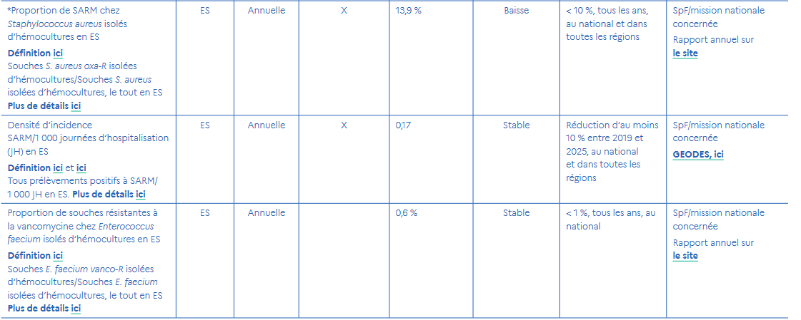  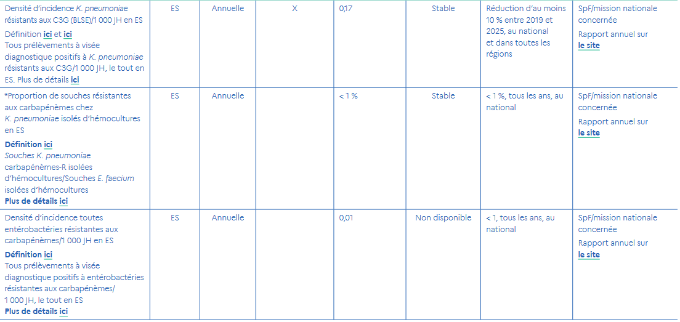  https://sante.gouv.fr/IMG/pdf/strategie_nationale_2022-2025_prevention_des_infections_et_de_l_antibioresistance.pdf
Objective | - Describe the local epidemiology of bacterial resistance to clinically relevant antibiotics  - Specifically quantify meticillin-resistant staphylococcus (MRSA), extended-spectrum betalactamase-producing bacteria (ESBL-), derepressed cephalosporinase- and carbapenemase-producing enterobacteria cephalosporinase and carbapenemase producers  - Collect national bacterial resistance indicators (Propias) using a standardized national method:  o Percentage of MRSA in S. aureus bacteremias occurring >= 48h  o Incidence density of MRSA bacteremias >= 48h  o Incidence density of K. pneumoniae and E. cloacae ESBL bacteremias >= 48h  o EPC (enzyme producing enterobacteria) rate among K. pneumoniae bacteremias  o VRE (vancomycin-resistant enterococci) rate among E. faecium bacteremias  - Monitor changes in these indicators over time
Epidemiologic specification | A monitoring indicator must be able to take account of the exposure and the population studied: it therefore comprises a numerator, reflecting the exposure, and a denominator, reflecting the population likely to be exposed.
Numerator / event of interest | Number of BMR isolated from diagnostic samples from hospitalized patients, excluding duplicates (which means that patient microbiological records must be used as the data source).  % RESISTANCE % BMR/BHR TARGET INCIDENCE  Number of R strains at antibiotic tested Number of S. aureus R strains to oxacillin Number of antibiotic R strains
Denominator | - bacteria belonging to the same species, isolated under the same conditions, excluding duplicates, to generate species prevalence indicators  - number of direct admissions (i.e. excluding domestic passages) and complete admissions (i.e. for hospitalization > 24 hours) and number of complete hospitalization days (i.e. corresponding to hospitalizations > 24 hours) during the survey period, which makes it possible to generate incidence indicators, more informative than the previous ones.  % RESISTANCE % BMR/BHR TARGET INCIDENCE  total number of strains (S+SHD+R) total number of S. aureus strains (S+SHD+R) number of days hospitalized in the healthcare facility
Adjustment | Data deduplication :  The following definitions refer to the “Methodological recommendations for monitoring antibiotic resistance in microbiology laboratories”, published by ONERBA1.  - A duplicate is a strain isolated from a patient for whom a strain of the same species and antibiotype has already been taken into account during the diagnostic period (no screening).  - Antibiotype refers to the micro-organism's sensitivity/resistance profile to the various antibiotics tested.  -> Standard-dose (S) and high-dose (SHD) susceptibility categories should be grouped together.  -> The antibiotype differs if there is a major difference (S <-> R) in clinical categories between the strains compared, for at least one molecule  -> The deduplication also covers the resistance phenotype (presence or absence).  -> Only the total number of strains and the number of resistant strains after deduplication are requested.
Data source | Hospital Clinical Data Warehouse (HCDW)
Form of result
List of variables necessary for indicators and metrological assessment | 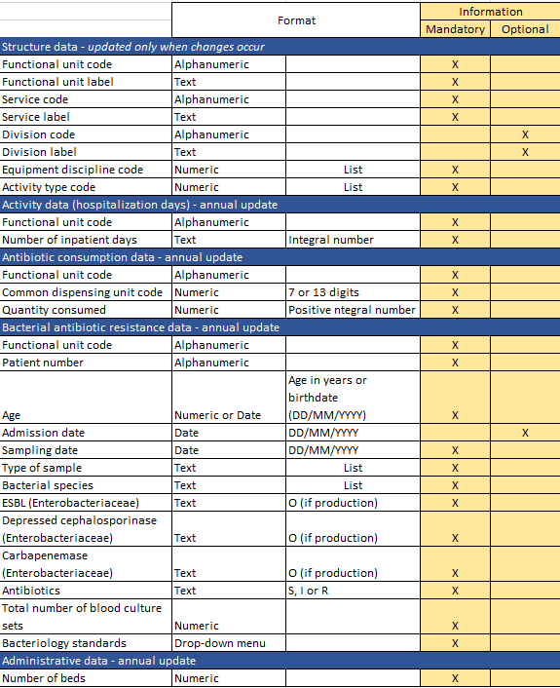  SPARES national methodology v.30012013
Output format | graphic representation (e.g. curves, histograms, bar charts) and interpretation rules
Distribution process | frequency of result production, target audience for the results, and access mechanisms (e.g. internet platform), including whether there is open access for the general public
Ethical requirements / recommendation

Technical specifications
technical documentation needed to move from general definition of indicator to calculating it in a reproducible way
Numerator / event of interest | variables / sources / algorithm
Denominator | variables / sources / algorithm
Adjustment | variables / sources / algorithm
Calculation method | calculation formula / calculation conditions (e.g. minimum number...) / mathematical model (e.g. predictive model, time series, ratio...)
Output format | graphical representation / comparator calculation method
Data Management | Data Format/ Data collection tools, Unique identifier, etc.
Indicator calculation version | date and version

Metrological properties
Development phase
Definition | approval process for the general definition of the indicator: sources of information used (e.g. bibliography, expert opinions, working group, etc.) and validation method (e.g. meeting, consensus, etc.)
Algorithm | approval of the lists of variables (or calculation algorithm) by experts according to the general definition
Empirical measurement | description of the method (e.g. data period, etc.)  main results (e.g. number of calculable events depending on data source, number of missing data depending on data source, production time depending on data source, etc.)
Validation phase
Comparison with a gold standard | carried out or not / if carried out: description of method (e.g. number of health records analysed, study period, records selection method, evaluation method, etc.)  main results (e.g. estimated positive predictive value, analysis of false positives),
Comparison with other indicators | carried out or not / if carried out: choice of indicators, description of sources  main results (e.g. correlation analysis)
Adjustment | carried out or not / if carried out: choice of adjustment variables (method used), choice of adjustment method, description of statistical analysis method  main results (e.g. comparison of observed and adjusted results, performance of statistical models)
Comparison over time | carried out or not / if carried out: description of method used (e.g. predictive model using time series)  main results (e.g. estimated accuracy of indicator measurement, identification of alert threshold)
Use phase
Comparison between hospitals | carried out or not / if carried out: choice of comparison method, description of comparison method, definition of comparator  main results (e.g. dispersion relative to comparator, identification of atypical entities)
Data visualization | evaluated or not / if evaluated: description of evaluation method  main results (e.g. users' opinions on how the results are reported and interpreted)
Date | date / study period metrological quality results

